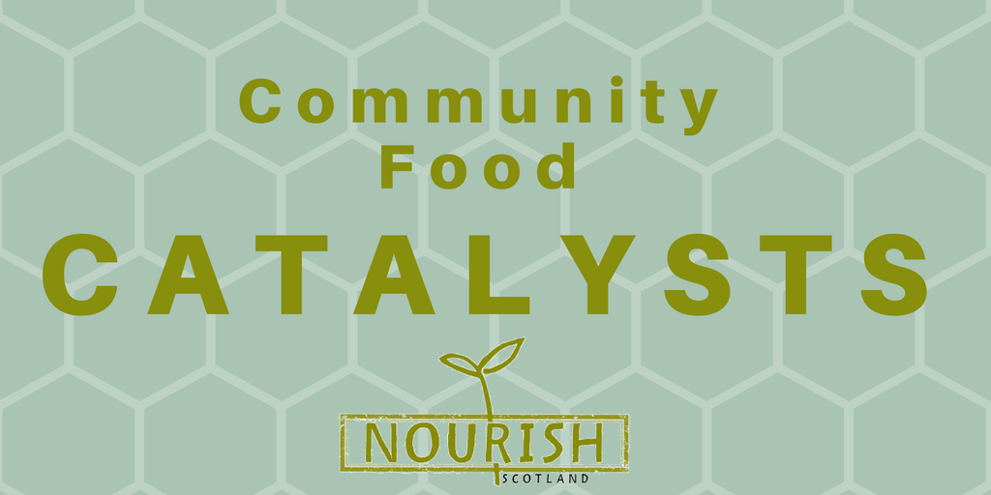
Feedback Template

This feedback template is to support you to reflect on and analyse what was said during your Community Conversation on food, fairness, and policy.

If you’d like a refresher on the semi-structured activities and facilitation tools we introduced in the training, take a look at the Suggested Outline for your Conversation handout. You can do things differently if you want to!

Don’t forget – not everyone in your Community Conversation may want their name attributed to comments, make sure you’ve anonymised or generalised appropriately.

Don’t forget – we need these completed by the 23 February 2017.

Some details about your conversation

Q: Where and when did it take place?
Were your participants part of any group or organisation? If so, which one?
How many people were there? How would you describe the make-up of the group?
Did you send a letter to your local MSP at the end?

NB If your participants were interested in receiving updates from Nourish, there’s a sign up sheet at the end of this template.

1: Childhood Food Memories

This activity was intended as a bit of an icebreaker– to get people thinking about their own relationship to food, and how this can change over time. Reflections on this section won’t be included in the consultation response, but if you do want to share something here we will keep it in mind

Don’t forget – this activity can be very emotive for some people, be prepared.

2: Personal Food Policy

The purpose of this activity is to get people thinking about policy & principles.

Your policy is what you do, the principles that underpin this are why you do what your do.
Eg: So if your policy may be to only buy fairtrade certified products, the principle is ensuring producers receive a fair price.

Remember there can be many principles that underpin what people in your group do – the prompt sheet is there to give people some ideas but it is not comprehensive. Remember also that people may have conflicting principles – our role as facilitators is not to tell people what is right or wrong, but to listen.

Q: Defining policy: What did people in your group think policy means?
Did people have conflicting ideas?
Q: Identifying personal food policy & principles: Were people in your group able to identify a personal food policy and the principles that underpin it?
Can you give some examples?

3: Barriers

The purpose of this activity is to get people to identify barriers that prevent them from fulfilling their personal food policy.

Remember that many of the barriers people face are interlinked.

Q: What barriers came up in your group?
How did people feel about this?
Did people make links between the various barriers and/or identify any root causes of these barriers?

4: Breaking Down Barriers

The purpose of this activity is to reflect on the role decision-makers can have in breaking down barriers.

We know communities do a lot to break down barriers but we are thinking specifically about decision-makers here – particularly MSPs & local councillors, and what they could do through policy & law – especially the forthcoming Good Food Nation Bill.

Q: What did people think decision-makers could do to break down barriers?
Were there different views in the room?
Did people feel that a Good Food Nation Bill would be a good vehicle for solving those problems?

5: Policy Principles

The purpose of this activity is to think about what principles would underpin the policy changes people identified in the previous activity.

For example – if people in your group feel that decision-makers should pass policy to increase wages, the principle that underpins that might be to protect minimum standards. The prompt sheet is there to give people some ideas but it is not comprehensive.

Q: What principles did people think should underpin policy and law on food?
Did people have conflicting ideas?

6: Participation

The purpose of this activity is to think about how decision-makers could make the Good Food Nation Bill process more inclusive.

A public consultation traditionally involves an outline of the issues being consulted on and a number of specific questions, often asked through an online form – this isn’t always the best way to encourage broad participation.

Q: What did people in your group feel would make it easier for them to be involved in the Good Food Nation Bill process?
Did people suggest any particular participation techniques or methods?
Did people reflect on any examples of where techniques have been applied?

Open space

This space is blank for you to write anything else you’d like to.

How did you find organising the Community Conversation? Did anything come up that surprised you or that you found challenging? How was the atmosphere in the room? Do you think your group would be keen to take part in more things like this?

Reflections on this section won’t be included in the consultation response, but if you do want to share something here we will keep it in mind.

 |  |  | Do they want to be kept updated on (please tick):
Name |  | E-mail address |  | Nourish  Scotland | The Good Food Nation Bill
Contact details

Please fill this in if people were keen to stay in touch!

Please email this back to Nourish Scotland by the 23 February on the email address: catalysts@nourishscotland.org.uk

Or you can post it to us at: Nourish Scotland, Summerhall, Edinburgh EH9 1PL

