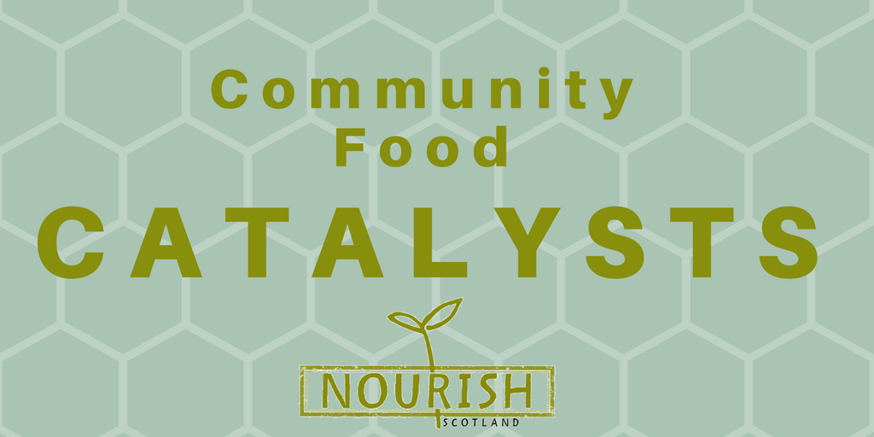
Date:
Place & Postcode:

Dear MSP

Today we held a conversation in our community about food justice issues, as part of Nourish Scotland’s Community Food Catalysts programme. As our local MSP, we would like to share with you some of the outcomes of our conversation. We hope that this will inform your thinking about food policy in Scotland and that our ideas will feed into the development of the up-coming Good Food Nation Bill as well.

Name of our community / group:

These are some of our “personal food policies” and the values that inform them:

These are some of the barriers we experience that get in the way of us being able to implement our food policies:

These are some of the things we think you and other decision-makers in Scotland can do to help break down these barriers:

These are the key principles that would underpin the food policies and interventions we identified:

This is how we’d like to be involved in the consultation process of the GFN bill:

We’re looking forward to hearing your thoughts. You can contact us using the following details:

You can also contact Nourish Scotland about the Community Food Catalysts programme at catalysts@nourishscotland.org.uk and/or find more information at www.nourishscotland.org/projects/community-food-catalysts/

Thank you and kind wishes,

