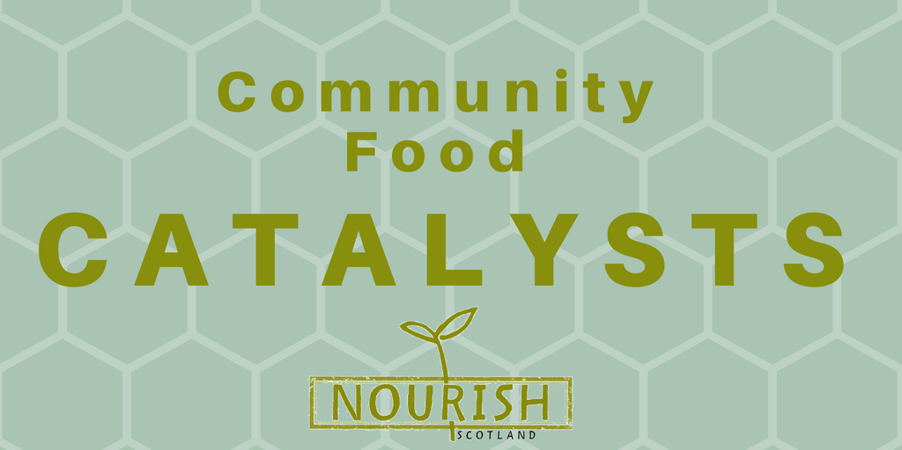

Suggested outline for your community conversation

1. Welcome & introductions

2. Childhood food memories & rules

Questions:
- What was food like when you were young? What do you remember?
- Were there any rules around food and eating in the household you grew up in? Which ones?

3. Personal food policy

- Start with a quick “brainstorm” of what people think about when they hear the word policy, and take notes on a board or piece of paper.

- Introducing policy, e.g.:
We can think about policy as a set of principles, rules, and guidelines by which decisions are made. Policies are formulated or adopted by a group of people, a business, an organization, a government, or a political party to reach their long-term goals. Individuals also hold values that guide their decisions, or set rules for themselves (such as our New Year’s resolutions…), which we can think of as our personal policies. Everyone has some rules and guidelines as they make decisions about what foods to eat and/or to serve their families, and where and how to get those foods. It can be about getting enough calories to have energy for the day and there can be other things informing our food choices too. This we can call “personal food policy”.

- Questions:
  - What is your “personal food policy”? What rules and guidelines have you set for yourself that inform your choices?

- Introduce principles/values:
We define values or principles as that what we think is important in life. They form the foundation for the rules we set for ourselves.
Give an example, such as: I choose to buy my food directly from a local farmer because I feel it is important to support those who did the hard work, instead of most of the profits going to the retailer. So the value of fairness underlies my policy.

- Question:
  - What principles/values inform your personal food policy?
You can use the values/principles template for this part of the conversation.

- Suggested listening exercise in partners. In turns, people ask about the other person’s food policy and values: Why do they feel this is important? What has shaped their policy? + Other open questions they want to ask.

4. Barriers

Questions:
- How do you feel about how you interact with food at the moment?
- What gets in the way of you “implementing” your personal food policy? What are the most important barriers?

5. Breaking down barriers

Questions:
- What are decision-makers responsible for in terms of breaking down some of these barriers? What could they do at which level?
- What policies could they develop and implement?

6. Policy principles

You can use the policy principles template for this part of the conversation.

Question:
- What are the key principles that would underpin the policies and interventions we identified?

7. Participation in food policy

Introduce the up-coming Good Food Nation Bill.

Questions:
- How could decision-makers make it easier to include you in the consultation process of the GFN bill? How would you want to be involved?

8. A letter to your local Member of the Scottish Parliament

If you want, write down the outcomes of your conversation on the template we’ve provided, to share with your local MSP. Let everyone sign it. You can also invite your MSP to have a meeting with your group. And don’t forget to send it afterwards! ☺

