Groceries Code Adjudicator Review: Part 2 -
Call for Evidence
We have identified below the specific categories of stakeholders which we consider are best placed to provide evidence of any market failure in the UK groceries supply chain. However, this is a public consultation and we also welcome views from any other parties on the points raised.
A copy of this call for evidence can be found at: www.gov.uk/government/consultations/groceries-code-adjudicator-extending-its-remit.
You can also complete your response online through: https://beisgovuk.citizenspace.com/gca/groceries-code-adjudicator-review-part2.
Alternatively, you can e-mail or post the completed response form to:
GCA Review Team
Victoria 316
Consumer and Competition Policy Directorate
Department for Business, Energy and Industrial Strategy
1 Victoria Street
London
SW1H 0ET
Email: GCAreview@beis.gov.uk
The closing date for the Review is 10 January 2017.
Information provided in response to this consultation, including personal information, may be subject to publication or release to other parties or to disclosure in accordance with the access to information regimes. Please see the consultation document for further information.
If you want information, including personal data, that you provide to be treated as confidential, please explain to us below why you regard the information you have provided as confidential. If we receive a request for disclosure of the information, we shall take full account of your explanation, but we cannot give an assurance that confidentiality can be maintained in all circumstances. An automatic confidentiality disclaimer generated by your IT system will not, of itself, be regarded as binding on the department.
I want my response to be treated as confidential ☐
Comments: Click here to enter text.

Questions
Name: Celia Nyssens
Organisation (if applicable): Nourish Scotland
Address: 1 Summerhall Place, EH9 1PL Edinburgh
Telephone number: 0131 226 1497
Email address: celia@nourishscotland.org.uk

Please check a box from a list of options that best describes you as a respondent. This allows views to be presented by group type.
 | Respondent type
☐ | Business representative organisation/trade body
☐ | Central government
☒ | Charity or social enterprise
☐ | Individual
☐ | Large business (over 250 staff)
☐ | Legal representative
☐ | Local government
☐ | Medium business (50 to 250 staff)
☐ | Micro business (up to 9 staff)
☐ | Small business (10 to 49 staff)
☐ | Trade union or staff association
☐ | Other (please describe) Click here to enter text.

Questions relevant to retailers
(i.e. retailers mentioned in Article 4(1)(a) and (b) of the Groceries Supply Order).
1. Are you currently covered by the Code?
☐ Yes
☐ No
2. If yes, what is the impact of being in scope of the Code on your business, suppliers and consumers?
Comment: Click here to enter text.

3. If no, what do you think would be the impact on your business, suppliers and consumers if you were in scope of the Code?
Comment: Click here to enter text.

4. What changes, if any, do you think are needed to the grocery supply chain to ensure fair practice, whilst ensuring that, over the long term, consumers face no extra costs?
Comment: Nourish Scotland supports extending the Groceries Supply Code of Practice, and thereby the remit of the GCA, to include indirect suppliers, in particular primary producers and farmers. We believe regulation of the groceries sector should follow the principle of ‘responsibility across supply chains’ set by the Modern Slavery Act (2015), i.e. commercial organisations must ensure that slavery and human trafficking is not taking place in any of their supply chains, nor in any part of their own business. The principles set out in the Code should apply across entire groceries sector, and retailers should be liable for practices further down their supply chains.
In addition, we believe a principle of fair pricing should be added to the Code with the aim to better distribute profit along supply chains. Retailers, wholesalers, and manufacturers should be forbidden from putting pressure on their direct suppliers to provide merchandise for less than the cost of production. This would ensure that consumers’ money spent on groceries filters through to the primary producers, with no extra cost to consumers.

5. What impact do you think any changes you identify will have on the competiveness of the grocery sector?
Comment: The extension of the Code to the whole groceries sector would ensure fairer trading practices across the whole groceries sector. This will be in the advantage of all suppliers, but most particularly of smaller direct and indirect suppliers, which will in turn be positive for the competition in, and competiveness of, the sector. The 2016 YouGov Survey into the work of the Groceries Code Adjudicator (GCA) showed that smaller suppliers are more likely to benefit from the work of the GCA, but are also less aware of the GCA’s role and of Code-related training opportunities. It is therefore crucial that the extension of the remit of the Code is accompanied by an increase in the resources available to the GCA for their advisory, outreach, arbitration, and investigatory role.
Eventually, consumers will benefit as the available choice is maintained and enhanced and fairer supply chains translate into fair retail prices.

6. Can the changes you propose be achieved in a non-legislative way?
Comment:

7. Do you have any views or evidence on the possible costs of extending the GCA’s remit?
Comment: Click here to enter text.

8. Are there any additional issues you would like to bring to the attention of the Call for Evidence?
Comment: Click here to enter text.

Questions relevant to suppliers
1. Where do you fit into the grocery supply chain?
☐ Direct supplier covered by the Code
☐ Indirect supplier
☐ Other
Comments: Click here to enter text.

2. How many people work in your business?
☐ Up to 9
☐ 10 to 49
☐ 50 to 250
☐ Over 250
3. For the last financial year please provide an approximate estimate of the following:
a) Annual turnover of your business
Comments: Click here to enter text.

b) The price – cost margin
Comments: Click here to enter text.

c) Fixed costs of production
Comments: Click here to enter text.

d) Profit and loss
Comments: Click here to enter text.

e) Number of customers
Comments: Click here to enter text.

f) State what Units you are using (e.g. £ sterling?)
Comments: Click here to enter text.
4. Did your business grow in the last financial year?
☐ Yes
☐ No
5. What, if any, are the barriers to growing your business?
Comments: Click here to enter text.

6. What are the major challenges you face in investing in your business and their resultant impact?
Comments: Click here to enter text.

7. In your view, are there any behaviours in the grocery supply chain that are unhelpful but not covered by the Code, either because they are new behaviours not identified in the Code or because the behaviours are affecting businesses who are not direct suppliers to the grocery retailers?
Comments: Unfair pricing is a significant issue in the groceries sector, in particular towards primary producers, and is not currently covered by the Code. This behaviour is not new, but has increased in recent decades due to very tough competition in the groceries sector putting downward pressure on prices.
Risk and profits are distributed extremely unfairly along supply chains. While farmers bear a considerable part of the risk, they get low rewards for their produce. British farmers produce 62% of the food that is eaten in the UK, yet they only get 9% of the Gross Value Added of the whole food and farming sector (see Figure 1 in Annex). This figure illustrates how much profit is made in long supply chains, but how little profit filters through to primary producers. Furthermore, retail prices have risen faster than farm-gate prices for many food items, and primary producers are sometimes forced to sell their produce at a loss. This reality was brought into broad daylight in the recent dairy crisis but exists in other sectors as well. Farm Business Income data from across the UK illustrates that the average farm does not make any profit from its agricultural output (see Graph 1 and 2 in Annex). This poses a great threat to the agricultural sectors and to the future quality and choice available to consumers. Nourish Scotland believes the addition of a principle of fair pricing in the Groceries Supply Code of Practice is a necessary measure to start addressing this significant issue.
Furthermore, primary producers are not currently covered by the Code and therefore not benefiting from the improvements observed in retailers’ relationships with their direct suppliers in recent years. The five principles that are enshrined in the Code and from which primary producers would benefit most are: the principle of fair dealing; no retrospective variation of supply agreement; no variation of supply agreement without reasonable notice; no significant changes to supply chain procedures; and no delay in payments.

8. What impact do these behaviours have on your business and on consumers?
Comments: Unfair pricing has a disproportionately negative impact on smaller suppliers, who are less able to negotiate fair prices and tend to have higher costs. Small suppliers have an important place in the British groceries sector, and risk being squeezed out by tough competition combined with unfair trading practices.

9. Have you ever challenged these behaviours?
☐ Yes
☐ No
If yes, how? Click here to enter text.
If no, did anything stop you from challenging them? Click here to enter text.

10. Have you ever sought external advice/support in dealing with these behaviours?
☐ Yes
☐ No
If yes, who did you approach and what support did you receive? Click here to enter text.
If no, did anything stop you? Click here to enter text.
11. What are the top two or three priorities in the groceries supply chain that you feel will benefit your business most if addressed?
Comments: Click here to enter text.

12. What steps do you think are needed to address these priorities that are not now being taken?
Comments: Click here to enter text.

13. Are there any non-legislative steps that can be taken?
Comments: Click here to enter text.

14. What do you perceive would be the impact of expanding the GCA remit?
Comments: An extension of the remit of the GCA alongside an increase in the resources available to them and their team would have a considerable positive impact on the groceries sector. Fairer supply chains will promote healthier competition in the sector and stop the race to the bottom that is currently the norm.
The addition of a fair pricing principle in particular could have far-reaching benefits for the food and drink (including farming) sector. The current concentration of profits in narrow sections of groceries supply chains is detrimental to the economic sustainability of the sector.
Improved security and confidence could help primary producers as well as processors make long-term investments – for example to increase the sustainability or health-value of their produce – that will have wider benefits for consumers and society as a whole.

a) Could these be achieved in a less regulatory way?
Comments: Click here to enter text.

b) What impact do you think this will have on consumers?
Comments: Click here to enter text.

15. Are there additional issues you would like to bring to the attention of the Call for Evidence?
Comments:

Annex

Graph 1 Distribution of performance (a) across farms 2014/15; England only 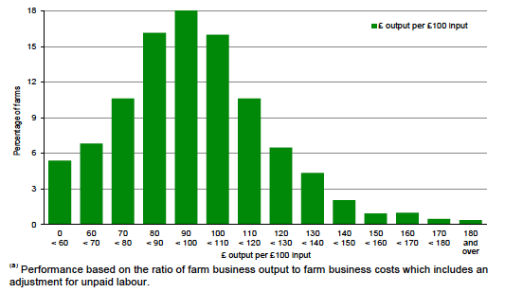
Source: Agriculture in the UK 2015 – DEFRA

Graph 2 Farm business income by cost centre; Scotland only
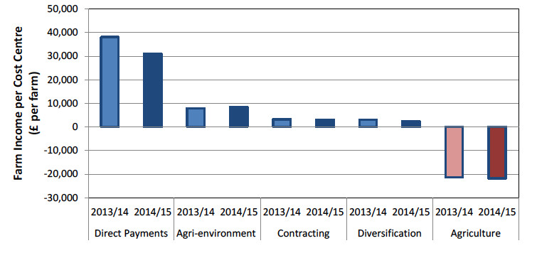
Source: Annual Estimates of Farm Business Income – Scottish Government, March 2016.

Figure 1 Gross Value Added in the Food and Farming sector 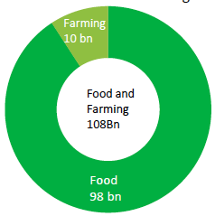
Source: Agriculture in the UK – DEFRA Seminar 27th June 2016 – Presentation by Vic Platten, DEFRA Food and Farming Strategy and Innovation

BEIS/16/29RF

