Stop Climate Chaos Scotland Briefing

Greener Farming – and the need for a Nitrogen Budget
Is farming a big emitter of ghgs?
In Scotland the Agriculture and Related Land Use sector is the 3rd largest emitter of ghgs after Transport, and Energy generation. 2015 figures show it accounts for 10.8MtCO2e or 22.5% of Scotland’s emissions. Importantly, farming is the biggest emitter of methane and nitrous oxide (N2O) both powerful ghgs. Methane is mainly produced by cows & sheep (and landfill) and is 25 times more powerful than CO2; N20 is released when fertiliser breaks down in the soil (and from transport) and is 310 times more powerful than CO2.
What activities cause emissions on-farm?
In the national inventory of climate emissions only ghgs from activities on farm or on land are included in this sector, e.g. ghgs from livestock, manure management, fertiliser spreading, converting grassland to cropland. What is doesn’t include is emissions from the manufacture of fertiliser (large), processing and delivery of food after it leaves the farm. Nor does it count the emission savings from on-farm renewables or from tree planting on farms as these are counted elsewhere. Calculating emissions from farm practices is far from straightforward and research continues to improve the estimates of ghg losses.
Why is SCCS focussing on the agriculture sector?
Farming has reduced emissions since the 1990 baseline year – by 25.8% up to 2015. The majority of this is a result of non-climate policies or market changes - Government has not introduced any significant climate policies affecting the agriculture sector so far. The Farming for a Better Climate (FFBC) initiative is purely voluntary and focussed on advice, and climate related activities through Scotland’s Rural Development Programme are limited in scope. The Climate Change Plan was the opportunity to introduce the most basic regulation, such as compulsory soil testing and carbon audits but, late in it development, Ministers decided against compulsory measures.
Are we blaming farmers?
There is a huge variety of farm types in Scotland, from arable in the east to sheep farming in hills, to crofting, so ‘one size fits all’ regulation isn’t always appropriate. Many farms are small businesses and have few staff – average is 1.2 FTE staff per farm, and many could not survive financially without subsidy. Like other small businesses they are under pressure and follow market signals and policy incentives. There are, however, some vocal farmers who block imposed regulation, despite demonstrable benefits to farm businesses. Government policy is needed to set direction towards greener farming and to introduce the policies and mechanisms needed to make it happen.
What can farmers do?
Installing renewables, planting trees and looking after soils can cut emissions and help farming to be more resilient to climate impacts. A key way to cut the ghg N2O is for all farmers to use nitrogen fertiliser more efficiently in order to cut nitrous oxide emissions. A basic soil test and a carbon audit are fundamental to planning how much fertiliser to spread and to reducing surplus and wasting resources. This could help to cut the 161,000t surplus use of nitrogen as seen in 2104 – equal to the tonnage of nitrogen in chemical fertiliser spread that year. A switch to spreading composts, manures and slurries as fertiliser would prevent the need for manufacturing high-carbon chemical fertiliser. To make this happen Government could include some key policies in the Climate Bill:

- Set a increased target for farmers farming organically
- Introduce a Nitrogen Budget for Scotland with targets

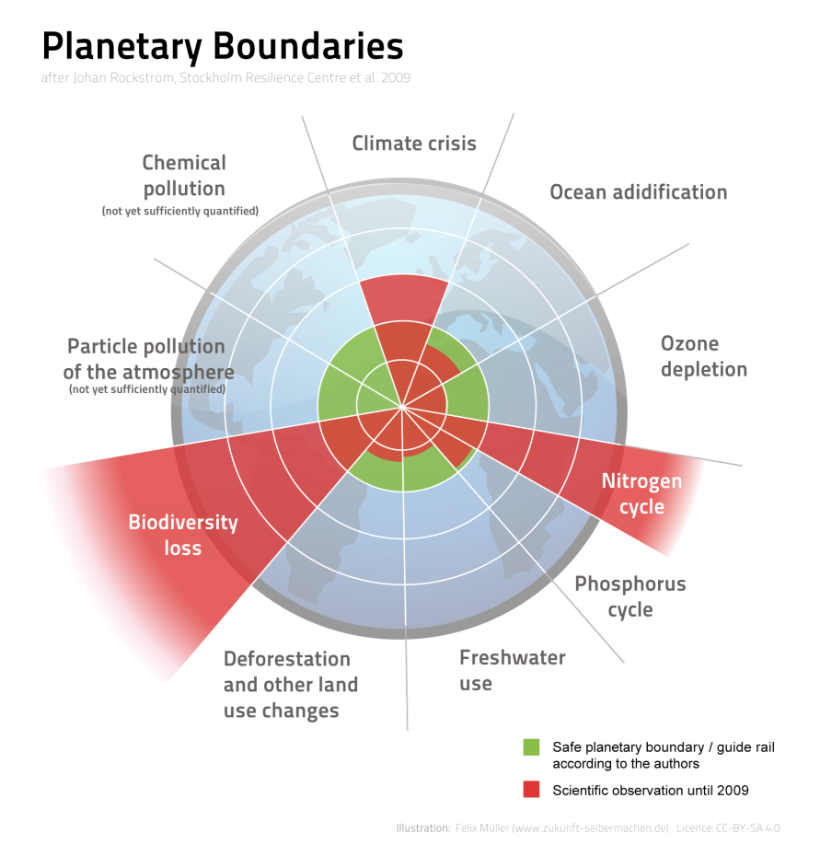
Why is nitrogen a problem?
Nitrogen itself is not a ghg but to take it from the air and put it in chemical form is highly carbon-intensive process. When in chemical form the nitrogen is readily available for plant growth and industry but is also highly mobile and can easily be lost to the environment as pollution. As a consequence we are exceeding the planetary boundary for nitrogen in the environment.
What is a Nitrogen Budget?
A Nitrogen Budget aims to cut the overall amount of chemical fertiliser spread on Scotland’s fields and promote recycling of biodegradable materials like food waste. It would firstly help Government better understand the amount and flows of nitrogen we use in Scotland from fertiliser factory to fork, from field to food waste, from sewage treatment to seas. A Nitrogen Budget would help in developing fair policies which cut nitrous oxide emissions and other nitrogen pollution, and promote recycling. It would help to identify where nitrogen-containing materials are lost or wasted, and in developing mechanisms to recycle these, making a more circular economy for valuable biodegradable materials. Better understanding of nitrogen use and flows would give confidence to set national targets for reducing nitrogen imports and make us more self sufficient in growing our own food.
What are the other benefits of a Nitrogen Budget?
Additional benefits include:
- Reduced costs for farmers, as they use costly fertiliser more efficiently.
- Improved carbon levels in soil as farmers switch to biological fertilisers.
- Supports a cut in food waste – Scotland is aiming for a 33% cut by 2025.
- A new market for biological ‘waste’ materials and impetus for anaerobic digestion businesses
- Improved water quality as excess nitrogen fertiliser is prevented from entering watercourses.
- Increased biodiversity as overuse of fertiliser has badly affected habitats and species
Has any other country done this?
Researchers in Denmark have developed a Nitrogen Budget. It has helped Denmark to understand the movement of nitrogen between different forms and sectors, and can be used to inform policies to drive further efficiency savings and reductions in nitrogen losses to the environment.

http://www.gov.scot/Publications/2017/06/9986
http://www.gov.scot/Resource/0051/00518694.pdf
http://iopscience.iop.org/article/10.1088/1748-9326/9/11/115012/meta;jsessionid=A63013AA760A4D55BFCDBA4B258E3F1C.c1

