Developing a Dignity Framework for Community Food Provision:
Results from Focus Groups and Workshops
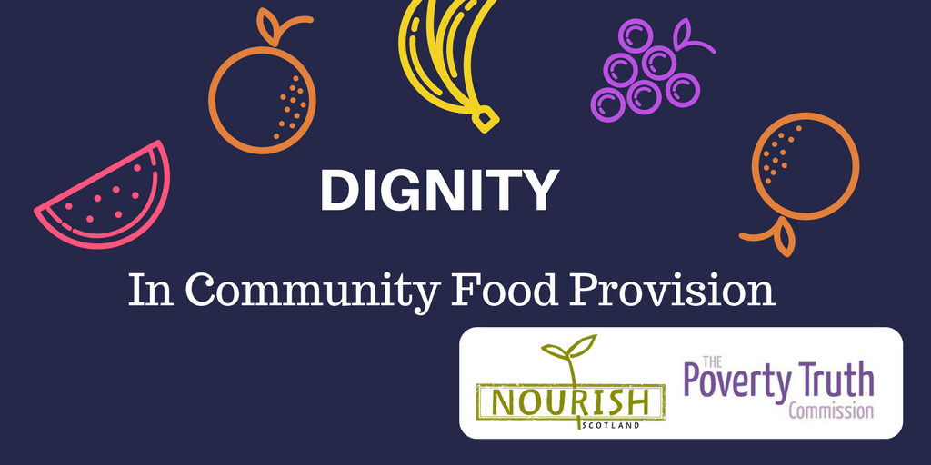
What is Dignity?

The central theme for this framework is Dignity in Community Food Provision, and each focus group and workshop asked for participants’ views of what Dignity means to them.

The following explanation is drawn from the common, clear and consistent messages that emerged from all of these discussions:

Dignity is feeling like a human being, just like everyone else.

This means being:
- recognised as a whole person, with a full range of skills, experiences and stories to share and contribute;
- trusted as capable of making choices and deserving of the support and respect to do so;
- valued as an individual, regardless of your circumstances.

Focus Groups with those involved in services: Results

Four focus groups were held with a total of 33 people who have used community food service provision. These centred on:
- exploring the concept of dignity
- reflecting on examples of good practice
- reflecting on examples of challenging practice
- drawing out the principles that underpin dignified practice

When exploring the concept of dignity, people involved in the focus groups generally agreed that being food insecure is an inherently undignified experience. People felt that community food service provision can support people who have experienced crisis by restoring some degree of autonomy and control, by creating a space in which people are treated with empathy and respect, and a space which more generally tackles social isolation and creates a sense of belonging through fresh, healthy and fair food that is inclusive of everyone.

Thinking specifically of examples of community food provision that embody this people referenced places where you could choose food in accordance with your preferences and dietary needs, places where you have the opportunity to contribute and learn new skills, and places where you’re not singled out as someone in poverty but where people from all walks of life gather because they want to rather than need to.

Thinking specifically of examples of practice that could be improved, most people focused on food bank referral processes. There was consensus that needing a referral to access community food provision was foremost unnecessary and often caused confusion and embarrassment. People were also concerned that needing a referral meant that people who needed support were excluded because of a fear that social services may deem them unable to care for their children. More generally, people felt that a formal referral process was not the most effective way of working with partner organisations. Other examples of challenging practice included that food can be of low quality, may not nutritionally balanced, and there is often very limited choice in pre-made parcels.

Thinking of what principles underpin dignified practice, the issues people raised most often were choice, information, fairness, and inclusion. People wanted to feel like change can happen – both at a community level and at a political level to end food insecurity, and they wanted to be involved in making the change happen.

Service Providers Workshops: Results

Twenty-two people from 16 organisations participated in workshops held in Glasgow and Edinburgh in February 2017.

The Service Provider Workshops were divided into three sections:
- exploring the concept of ‘Dignity’
- considering how dignity could be placed at the centre of decisions about how people access their service
- considering how dignity could be placed at the centre of decisions about how people take part in their service

Dignity at the heart of accessing services
Reconising that a range of factors typically inform decisions about how services are accessed, participants were asked to consider the following question:

‘What would it look like if Dignity were at the heart of decisions about how people access your service?’

These decisions relate to the design of an organisation and should reflect the core purpose of the service (e.g. a project aimed at addressing food insecurity should be accessible to and inclusive of anyone experiencing food insecurity; a project aimed at building community should be accessible to and inclusive of anyone in the community).

Eligibility and Referrals
Participants had a wide range of policies about who could be involved in the service they offered. This included:
- Free and open to everyone in the community (e.g. community growing projects, weekly meals, holiday meals)
- Self-referral or informal referral (e.g. open to people who identify as needing the service, such as those experiencing food insecurity)
- Referral only (e.g. accessible only through formal referral from a separate agency or organisation)

Resource constraints meant that many services felt they needed to limit who could access food through their service. This had the potential of undermining a dignity by establishing and maintaining a referral system that distinguishes between those who ‘deserve’ support and those who do not. Given the agreement by all participants that Dignity means being treated ‘just like everyone else’, there are concerns about how this relates to the rationale for referral systems.

Duration of Involvement
Service providers described a range of approaches to how long people were involved with their project or service. This related in some cases to the eligibility points (above), and practices included:
- Open access, free to come as often and for as long as the person chooses (e.g. community growing projects, community meals, weekly soup gatherings, drop-in sessions for tea, biscuits and support)
- Semi-restricted access (e.g. a food parcel for three days worth of food, provided until ‘crisis’ is over, cookery classes delivered for a set period)
- Restricted access (e.g. a food parcel for three days worth of food, no more than three times per year)

Some groups made the point clearly that since they were engaged in community-building activities, they were committed to involving people for as long as each person chose to engage. As one person put it: ‘We want to build community, so we don’t put a time limit on it’.

Resource constraints meant that some projects were necessarily time-limited, for example when grant funding for a community growing project ended after six months, or cookery classes were only available for six weeks. A key concern was about how to build community with only short-term funding.

Services who placed restrictions on how long a person could use the service often explained that this was to ‘avoid dependency’ and to ‘help them get back on their feet’. Given the clear understanding that Dignity means ‘being treated as capable of making decisions’, this practice has the potential of undermining a person’s dignity, and it is important to consider what other factors may be involved in these decisions.

Location
Where a service is based relates both to how it is designed and delivered. For example, a service that is designed to build community is likely to be based in the centre of a community and in a place where people feel comfortable to go. Services designed to alleviate food crises tend to place greater emphasis on using a location that has sizable storage and packaging facilities.

In all cases, the venue should be accessible to everyone in the community and not congregate people in a location and time that distinguishes them from the general public as ‘destitute’.

Collaboration and Maximising Resources
A significant part of one discussion about access related to how service providers within a community could manage resource constraints, avoid duplication and provide a more dignified service through sharing of resources. For example some city councils have worked with community food providers to offer council premises free of cost. This enables the service to work out of a location that is more dignified because it is already heated (warm), on public transportation routes (accessible) and a place that people would go whether they were in crisis or not (accessible and non-stigmatising).

Dignity at the heart of taking part in services
Reconising that a range of factors typically inform decisions about how people take part in a service, such as resources and volunteer availability, participants were asked to consider the following question:

‘What would it look like if Dignity were at the heart of decisions about how people take part in your service?’

These decisions relate to the delivery of a project and are common to all community food providers (e.g. using a non-stigmatising venue; providing quality food that enhances, rather than diminishes, self-worth; creating a warm and friendly environment).

Location and Physical Environment
Decisions about where a service was delivered included:
- delivering the service from the organisation’s existing premises (e.g. a church-based project using the church hall and kitchen)
- using space that was available at a reasonable or no-cost rate (e.g. storing and dispensing food from donated premises)
- seeking new premises to bring the service to a place what was more convenient and accessible for people (e.g. into the town centre and on a public transport route; developing home delivery schemes)
- developing new community spaces to be accessible to all (e.g. community growing projects building sites within or beside neighbourhoods)

Resource constraints meant that many services were using donated venues, such as church halls, at the times and locations that were available. When these spaces were already thriving community centres, where people from the community went for a variety of reasons, this was a successful approach.

However, in some instances it was difficult to establish strong community building activities in donated venues that were not places people tended to go or felt comfortable. This approach therefore has the potential of undermining a dignified response to food insecurity by requiring people to travel to specific, and sometimes inconvenient, locations to collect food rather than accessing the food they needed in their local area at a time that is suitable.

Time of day and week
The time and day of opening varied widely among the participants, though most were open for a couple of hours one or two days per week. They worked hard to be available when they thought that participants would be able to attend, but there were considerable constraints on their opening times.

Most services explained that the time they were open depended on volunteer availability or the time that the premises was available, especially if the premises was donated. In both cases, these decisions were resource-driven and had the potential for undermining the dignity of the person who will be using the service (e.g. if they aren’t able to access the food because they are unavailable during working hours when most volunteers prefer to work).

Social Environment
The main point discussed in relation to how people delivered their service was about establishing a warm, welcoming and respectful environment for people who attended. This included:
- welcoming the person with a smile and chat
- offering the person a cup of tea and space to sit and relax
- treating people like you would treat a friend or family member
- sharing food and other activities together
- engaging with people at their own pace
- providing the service without conditions (e.g. not placing arbitrary restrictions on their involvement; not scolding people for their actions or withholding food as punishment or penalty)

An important element of how long people engaged with services was the time set aside to listen to people who wanted to share their stories, and knowing when to allow people opportunity to just share the space (or activity) without having to tell their stories if they did not want to. Many service providers worked hard to respond to how community members and participants were feeling and to recognise that it may have taken a lot for them to come to the service in the first place.

Food Quality and Choice
The quality, type and way in which this food is provided through community food services relates to the core aims of the service (design), but this is also a critical aspect of the delivery of a service. There is a wide range of methods for sourcing and making food available, which include:

Sourcing food
- dry and ambient foods donated through local collection drives (e.g. in schools, local businesses, churches) or through supermarkets
- dry, ambient and fresh food donated or purchased through partnerships with supermarkets and local businesses
- dry, ambient and fresh food purchased through unrestricted funds or donations to ‘top-up’ what has not been donated directly
- surplus food accessed through redistributor working across the food industry (e.g. FareShare)
- growing fresh produce together
Making food available
- food parcels in bags marked with foodbank name and/or logo
- food parcels in unmarked bags or bags from major supermarkets
- food parcels packaged in a standard format, available for collection at set locations or delivered to homes
- marking food to be distributed to prevent resale
- fresh foods (e.g. fruit, vegetables, milk and bread) provided as an optional ‘top-up’ to a standard parcel
- range of food presented on shelves (similar to a shop), for person to decide what and how much to take (e.g. by walking round and making a selection or selecting from a list)
- community larder stocked and made available without cost
- fruit barra offering low-cost fresh produce at a set location
- mobile fresh food shop offering low-cost food in pop-up locations throughout rural areas
- community cafes offering low-cost or free meals from a simple menu
- community meals, offering one or more option, which people prepare and/or eat together

The sourcing and provision of food are central to a discussion of dignity, yet these issues tend to be informed by resource considerations. For example, services often parcel food in advance of distribution because the venue is not suitable for presenting food for people to choose. Service providers often feel limited in their ability to offer choice because they rely on charity drives and the choices made by those donating. Services sometimes feel unable to keep and use fresh food because they rely on donated premises, which are only available to them for a few hours per week.

While it is important to understand these resource constraints, it is also important to recognise that these methods have the potential to place a person’s dignity at risk by:
- removing power over the choice of what to eat and
- undermining self-worth by providing food that others would not choose.
These are issues that will be explored in more detail through the Dignity Review process.

