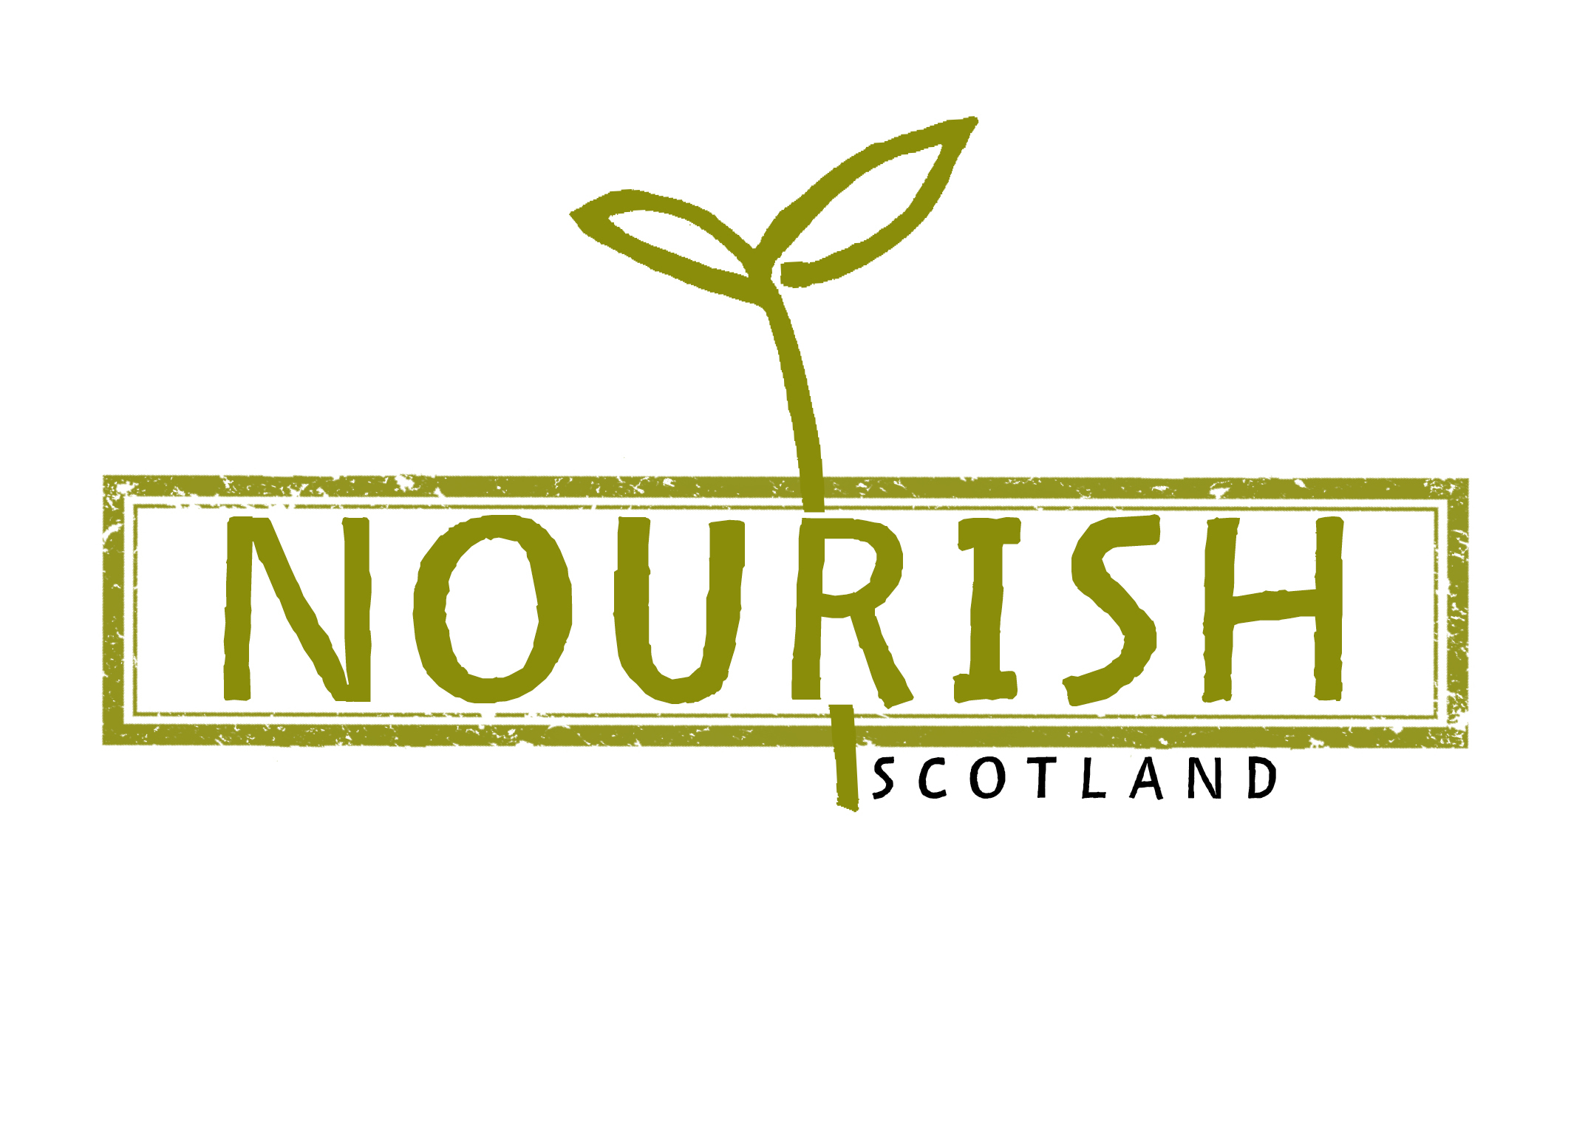
Nourish Scotland policy asks on food
Scottish Local Authority elections 2017
- May 2017

At Nourish Scotland we want to see flourishing cities, towns and communities centered firmly on the well-being of Scotland’s people, now and into the future. Support for public transport, active travel, renewable energy, waste management, schools and public services all form part of this picture – as does sustainable food. By investing in a healthier, more sustainable and fairer food system, our local authorities can deliver a whole range of social, economic and environmental outcomes. This draft election briefing outlines our headline policy asks on food for the Scottish Local Authority elections in 2017.

1. Develop Effective Cross-sector Food Partnerships

We want to see each Local Authority in Scotland develop an effective cross-sector food partnership that works to embed good food in policy and practice. Local Authorities could join the UK-wide Sustainable Food Cities network to advance this and learn from the experiences of Edible Edinburgh and the Glasgow Food Policy Partnership. Since many Local Authorities will be revising their Single Outcome Agreements in 2017, we ask for authorities to ensure that good food is considered as a tool for delivering local outcomes across all areas of policy. Lastly, we want to see Scottish cities join the 2015 Milan Urban Food Policy Pact, which has been developed by 40+ cities from every continent and has 132 signatory cities so far. It recognises the strategic role cities have to play in developing sustainable food systems and promoting healthy diets, and encourages international collaboration and knowledge exchange.

Case study: Brighton & Hove

Brighton & Hove was one of the first cities in the UK to take a citywide, strategic approach to food issues. ‘Spade to Spoon: Digging Deeper', a food strategy for Brighton & Hove, was developed in 2006 by a coalition of individuals and organisations articulating their common vision for a better local food system. The strategy has been adopted by Brighton & Hove City Council and the Local Strategic Partnership and embedded in other policies and strategies across the city. Spade to Spoon includes an ambitious but practical action plan involving over 50 partners in its delivery. An independent organisation, ‘The Brighton & Hoove Food Partnership’, was established to bring the action plan forward, report on progress, and deliver some of the actions. Based on experiences from different cities, the Sustainable Food Cities network offers a helpful briefing on how to develop a food plan.

2. Lead By Example in Public Sector Food

Public procurement of local and sustainable food is one of the most effective mechanisms for driving food system change, helping to create shorter, greener and fairer supply chains. It is time for our public sector bodies implement the new Sustainable Procurement Duty as set out by the Procurement Reform Scotland (Act) 2014. This commits local authorities to consider how through the procurement process they can improve the economic, social, and environmental wellbeing of the authority's area, and reduce inequalities in particular, and facilitate the involvement of small and medium enterprises and third sector bodies. As part of this we want to see all public kitchens in schools, hospitals and other public places source a minimum of 15% organic by 2020 over the next council period. The Soil Association’s Food for Life catering mark at Gold Level is one tool for delivering this. This is absolutely achievable in Scotland, laws in other European countries set much higher targets: 40% organic sourcing for public kitchens in France and 60% for Denmark. The public sector is also uniquely placed to increase access to freshly prepared, nutritious food for the most vulnerable in society, tackling health inequalities. We want to see 75% of all food served in public sector settings freshly prepared from unprocessed ingredients by 2021. This would require investment in skills development of catering staff, learning from the approach taken by the House of Food in Copenhagen.

Case study: Denmark

The City of Copenhagen has used ambitious organic food procurement targets to help meet citywide sustainable development and social justice goals for fairer, greener and healthier living. Around 90% of the food served in Copenhagen’s public kitchens is now organic. Increasing organic consumption is a key action to support the city’s ambition to become the world's first carbon neutral capital by 2025. The House of Food, which was established in 2007 as an independent, non-commercial foundation by the City of Copenhagen, has played a key role in the transformation of the city’s public food by providing training to catering teams of over 300 kitchens to date. These trainings have been about changing mindsets not just menus, working with the creativity of the caterers to cook with fresh, seasonal produce and less processed foods (“swapping the scissors for the knives”), use less but better meat and cut food waste – thereby staying within existing public food budgets. Currently, one third of all Danish municipalities are in the organic conversion process.

3. Increase Affordable Access to Healthy Food

We want Local Authorities to support local food producers, build stronger urban–rural links and increase access to affordable fruit and veg for local communities. We propose the following measures as a starting point:
- Subsidising farmers’ markets and creating covered markets;
- Using planning powers to support local and independent food retailers and restrict unhealthy food outlets;
- Supporting every school in Scotland to link up with a local farm and/or community growing project or plant their own orchard and veg garden by 2020. This will give children and carers an opportunity to produce, cook, and eat healthy food and enable practical soil to plate education.

Case study: Birmingham

In Birmingham, the Council has taken steps to reconfigure the food environment after it mapped takeaways near schools across the city and found that nearly three quarters of schools had a hot food takeaway within 400 meters. A policy forbidding planning permissions for fast food outlets near schools and forbidding more than 10% of units in any shopping district to be takeaways, has led to 15 out of the 36 applications for hot food takeaways being refused since the policy was introduced in 2012. The policy is now part of Birmingham’s Childhood Obesity Strategy developed by Birmingham’s Health and Wellbeing Board in 2013.
4. Develop & Support Dignified Responses to Food Insecurity

Household food insecurity has been rising in Scotland. We believe everyone in Scotland should have access to tasty, nutritious and culturally appropriate food as a right and with dignity. We call on all Local Authorities to work with others, particularly those with lived experience of food insecurity, to develop and implement Community Food Plans, as part of wider Food Strategies. This was one of the recommendations (no. 19) made by the Scottish Government’s Independent Working Group on Food Poverty in their 2016 report “Dignity: Ending Hunger Together in Scotland”. Reducing food insecurity and hunger should be central to these Community Food Plans and special consideration should be given to children. With a view to closing the attainment gap, support should go to school breakfast clubs, programmes tackling holiday hunger and measures increasing local uptake of Healthy Start Vouchers to 80% by 2018 from the current national average of 74%.

Case study: Wholesome Wave Foundation, US & the Alexandra Rose Charity, London

Wholesome Wave is a non-profit working across the United States, connecting the dots between farmers, businesses, local authorities, the health sector and communities. They believe poverty should never be an obstacle to eating fresh produce and coordinate a range of non-stigmatising food access programmes - benefiting over a million families and thousands of farmers. Initiatives include sourcing private and public investment to double the value of food stamps when spent at farmers’ markets on locally grown fruits and vegetables.

The Alexandra Rose Charity has been running a similar scheme in the London boroughs of Hackney, Greenwich and Lambeth. The charity gives out Rose Vouchers to families receiving Healthy Start Vouchers who are particularly at risk of food insecurity and/or diet-related diseases. The Vouchers are worth £3 per child every week (double if the child is under one year of age) and can only be redeemed at markets that sell fresh fruit and vegetables, thereby supporting local producers and independent retailers at the same time. By locating the Rose Voucher registration and distribution at children’s centers, the scheme also supports participants’ engagement with existing activities focused on health and wellbeing.

5. Increase Provision of Land for Food Production

We want to see areas of land safeguarded for food production in and around our cities and towns - with particular protection for Grade I agricultural land such as parts of the Edinburgh Green Belt. As provisioned for by Part 9 of the Community Empowerment (Scotland) Act 2015, Local Authorities should co-produce ambitious Food Growing Strategies with local communities, as part of wider Food Strategies, to ensure that everyone who wants to produce food can access land to do so - whether it is allotments, community growing spaces or farmland. We want to see Local Authorities re-investing in land to provide long-term, secure tenancies to local food producers and community-led food production (see Ask 6). Some of our local authorities’ common good land, which by law exists for the benefits of the residents of the former burghs, should be considered for agroecological food production. As a first step, we call on local authorities to implement the statutory duty placed on them by the Community Empowerment Act to establish and maintain a register of all common good property, and consult community bodies before disposing of or changing the use of common good assets.

Case study: Cambridgeshire’s Farm Estate

Lack of access to land to buy or rent securely is a big barrier for aspiring food producers in Scotland. The Smallholdings Act of 1892 enabled UK County Councils to create and let smallholdings as an entry route into agriculture. Fifty County Councils in England and Wales still maintain “County Farms", with in total 3,100 tenants on 111,000ha of local authority land, but this provision is shrinking, as budget cuts are forcing councils to sell off land. In Scotland, most County Farms were sold off years ago, leaving new entrants with either the private sector or crofting. In England, Cambridgeshire County Council has the largest "Farms Estate" in the UK, comprising 13,400ha and letting to 197 farm tenants. The Farms Estate provides significant financial returns for the Council, generating £4.1 million in rent each year. The money raised is used to pay for council services and to keep council tax low. Since 2000, the Estate has given 88 new entrants their first step on the farming ladder. As well as providing financial benefits the Council has used the Estate to open public access to the countryside by developing food paths and to protect biodiversity and cultural heritage.

6. Invest Council Pension Funds in Sustainable Food Production

Nourish supports the Reinvest Scotland campaign run by Common Weal, UNISON Scotland and Friends of the Earth Scotland that calls on council pension funds to divest from fossil fuel companies, aligning with Scotland’s climate change commitments, and reinvest strategically into the local economy. We want to see a proportion of these funds to be re-invested in sustainable food businesses as well as in farmland (see Ask 4.) as part of a wider socially responsible investment portfolio.

Case study: The Preston Model
While Scottish local authorities are coming under increasing financial pressure, in England the cuts have been affecting authorities already deeper and for longer. In this difficult climate, Preston Council has been leading the way over the past 7 years with reforms focused on supporting the local economy and tackling inequalities. They devised a model that involves 12 of the city’s key employers – including the county constabulary, a public sector housing association, colleges and hospitals – buying goods and services locally, to stop 61% of their procurement budget being spent outside of the Lancashire economy. A key step was to redirect public contracts, such as printing services for the police and food for council buildings, towards local businesses. The benefits of this shift for local businesses can already be seen. Conlon Construction, a family-run company, has hired five local staff and three graduate apprentices since it was awarded public sector contracts including one to build a new covered market hall. Local farmers profited when the council divided up its £1.6m food budget for canteen sandwich fillings, yoghurts and fruit and simplified the tender process. On top of this, they got their public pension fund to invest in student housing, are looking at setting up a local bank to give business loans and for the local authority to become an energy provider. Preston was also the first northern city authority to implement the living wage in 2012. “You put all that together and you can see how we are developing the infrastructure for a new economy”, Councillor Matthew Brown explains in this article.

7. Stop Spraying Pesticides and Start Growing Food in Public Spaces

We want to see Local Authorities ban the spraying of glyphosate and other pesticides on all public access land by 2018. Glyphosate was classified as “probably carcinogenic to humans” by the WHO and affects urban biodiversity. Several European countries, including France, Holland, Denmark and Sweden, have already banned or restricted the use of glyphosate and other pesticides by Local Authorities. Cornwall Council also recently put forward a motion to ban glyphosate both on public access land it owns or manages, and reduce its use on its County Farms. Instead of focussing on weed control, we can use sections of our parks and verges to grow vegetables, fruit and herbs for and with local communities.

Case study: Stirling

In 2011, the Stirling Council piloted the Edible Borders project, as part a two- year partnership between Going Carbon Neutral Stirling (a programme of Keep Scotland Beautiful) and Stirling Council. The project seeks to encourage citizens and communities to grow some of their own food and reduce their carbon footprint. As part of this, the Council’s Land Services team transformed seven sites across Stirling, including one in front of the council building, and planted a mixture of vegetables and herbs instead of traditional garden bedding plants. All of the produce from these beds was donated to the Salvation Army. Costs of the Edible Borders were not higher than what was previously grown, and the project employed three apprentices as part of the Modern Apprentices scheme. The project received local and national acclaim and has since been expanded into other areas, working together with local communities.

Get in touch!

If you have any questions or thoughts about this briefing, or are interested in campaigning on food issues in the run-up to the elections, please get in touch with Olga Bloemen at Nourish on olga@nourishscotland.org.uk, or call the Nourish office on 0131 226 1497.

